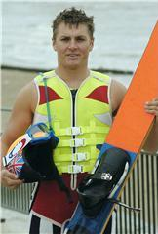Karl Brooks Memorial
2nd Annual Golf Tournament
January 16, 2009
Karl Brooks Memorial Golf Tournament / $120 per player, $135 after Dec.1
All Proceeds Will Be Awarded To: The Karl Brooks Memorial
Entry Fee includes: Green fee, golf cart, range balls, breakfast and dinner
Awards Reception and Dinner following tournament

9:30am Check In / 11:30am Shotgun Start – Scramble Format / 5:00pm Dinner
Golf Course: Temecula Creek Inn www.temeculacreekinn.com
Temecula Creek Inn Hotel Reservations (800) 962-7335
(Mention Karl Brooks Golf Tournament for discounted rate)

Sponsorship Packages

Gold Sponsorship $4,000 Golf and Putting contest for 12 Players, 4 Hole Sponsor Signs, Logo on Event T-shirt.

Silver Sponsorship $2,500 Golf and Putting Contest for 8 Players, 2 Hole Sponsor Signs, Logo on Event T-shirt.

Bronze Sponsorship, $1,000 Golf and Putting Contest for 4 Players, 1 Hole Sponsor Sign

Additional Sponsorships: Please contact to inquire about contest sponsorship availability
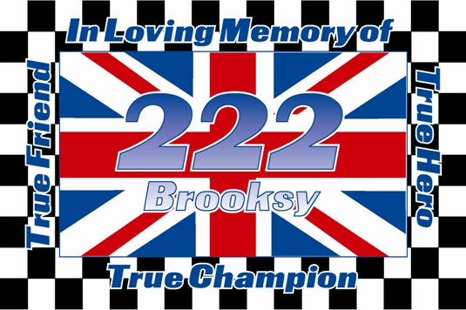Closest to the pin (3) $500, Long Drive (1) $500, Straightest Drive (1) $500, Putting Contest (1) $500, Hole in One (1), Breakfast Sponsor, Dinner Sponsor, Beverage Sponsor.

Sign me up for Teams of Four at $480 each

Sign me up for Players at $120 each

Dinner Only $30 per person

I would like to donate items for the Golf Gift Bags. To promote your business to the players, 150 gift bags will be assembled with identical contents, please plan on donating 150 of the identical item for the bags (koozies, golf tees, golf balls, coupons, water bottles, hats, shirts, towels, etc.)

I would like to donate items for the raffle. Raffle prizes will be given away at the awards reception and can be items such as DVD players, cameras, golf gift certificates, restaurant gift certificates, water ski equipment, concert/event tickets and more!

Contact Name: Sponsor Name:

Address:

Phone: E-mail:

Player Info:

Name: Name:

Name: Name:

Name: Name:

Name: Name:

Please make all checks payable to “Karl Brooks Memorial” and mail to:
Karl Brooks Memorial
618 Amigos
Redlands CA, 92373
Registration forms can be faxed and tee slots will be reserved when checks are received: FAX: (909) 335-8222
Contact Info: Justin Frank (909) 322-6284 justinRfrank@gmail.com
Todd Haig (951) 830-0781 todd@hondoframing.com

