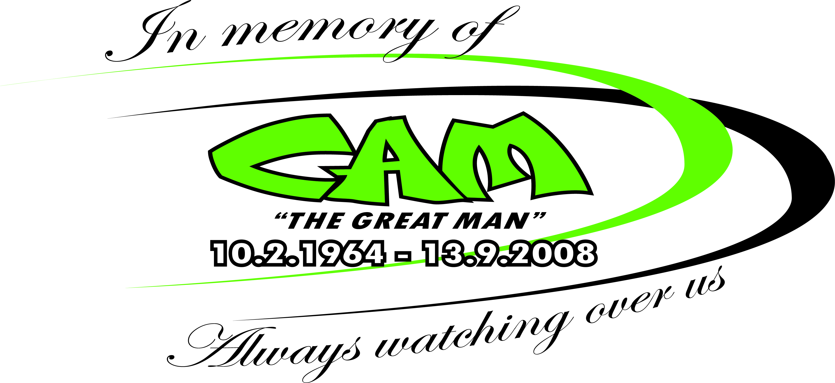 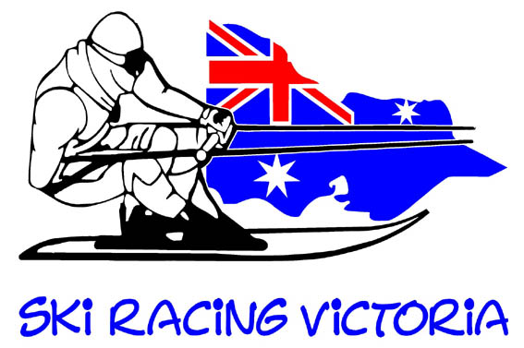

SRV JUNIOR DEVELOPMENT DAY 14TH NOVEMBER 8am TORRUMBARRY DOCKS

Only 4 weeks until the first of SRV’s Junior Development days. If you haven’t already registered please do to assist us with catering, boat and instructor requirements.

We still need a few experienced Skiers to assist with the tuition as well as a couple more race boats. If you are interested in supporting the Juniors please email [tonymithen@bigpond.com](mailto:tonymithen@bigpond.com) or phone Tony 0413886766.

This season Ski Racing Victoria will hold two Junior Development Days, the first at 8am on the 14th November at Torrumbarry Docks directly opposite All The Rivers Run Caravan Park Headworks rd Torrumbarry concluding at 5pm. The second on the 12th December with a possible third subject to interest and suitable date but most likely in February or March.

These training days are open to under 16 SRA members and will have a focus on developing skills in all facets of Ski Racing from Marathon to Social skis. Some of Victorias finest Skiers, Drivers and Observers will be on hand to provide expert advice. The Juniors will also receive tuition on pre race preparation including Exercise, Nutrition, Warm up and taping of ankles as well as Observer signals and Equipment Maintenance.

This is a fantastic opportunity for the Juniors to develop their skills while having some fun with their peers.

Email [tonymithen@bigpond.com](mailto:tonymithen@bigpond.com) to receive Registration form and SRA Waiver. $30 per child payable on the day. BBQ Lunch and Drinks will be provided. Registration is essential to allow for catering and crew numbers required. For further details phone Nathan Batchelor 0417133032 or Tony Mithen 0413886766

Thanks to Symes Motors for their Generous Support of SRV Junior Development



Contact Jason on 03 5445 1100 for all your motoring needs

Contact Jason on 03 5445 1100 for all your motoring needs