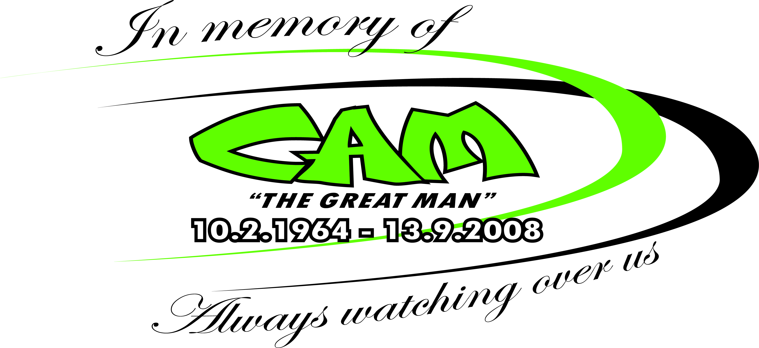 

SRV JUNIOR DEVELOPMENT

Registration Form

Name ______________________________

SRA Membership No ___________

DOB ________________

Phone Number _________________________

Email __________________________

Emergency Contact and Ph _________________________

NB: Separate entry required for each child

OFFICE USE ONLY

Payment received $30 Y N

Waiver Signed Y N



Contact Jason on 03 5445 1100 for all your motoring needs

___

Contact Jason on 03 5445 1100 for all your motoring needs

Contact Jason on 03 5445 1100 for all your motoring needs