


BULLETIN

SECOND
ROUND OF THE EUROPEAN CUP
OF WATERSKI
RACING 2014

May 30/31th

AUSTRIA
YB BS / Donau


Invitation

Ybbs, 28.December 2013
Dear friends,

It is a great pleasure for the Austrian Water Ski Federation and for the FZSV – Spk.Ybbs to invite you to the 2nd Race of the European Cup 2014 in Waterski Racing to be held on 30/31th of May in Ybbs an der Donau/Austria.

We are sure that all competitors will appreciate this wonderful site and we hope that many teams will compete in this event.
All competitors are welcome from Thursday 29.5. till Sunday 1.6

In this bulletin you'll find the information for competing in this race. If you need more information, please don't hesitate to contact:

Wolfram Kittl
Tel +43-664-6183978
E-Mail wolf.kittl@gmx.at

Ernst Ortlieb
Tel +43-664-4973923
E-mail ortlieb.ernst@gmail.com

Please pay attention:
The deadline for the entries will be the 26th April 2014.
Please send a list of your competitors with class, boatnumber, skier, pilot and observer
to the following addresse:

Wolfram Kittl
E-mail wolf.kittl@gmx.at

And bring the original signed entry and “Waiver and Indemnity” to the registration. The forms are enclosed to the bulletin.

We hope to see you all in Ybbs for a great and exciting competition.

Best regards,
Racing Committee
Wolfram Kittl, President

2014 European Cup
of Waterski Racing
Ybbs/Donau

Organisation Committee

President: Wolfram Kittl

Vice-President: Alois Schroll Mayor City Ybbs / Donau

Organising Committee Members: Mr. Patrick Kittl
Mr. Alex. Kittl
Mrs. Renate Brandstetter
Mr. Friedrich Haselsteiner
Mr. Herbert Schauerhofer

Driver starting boat: Mr. Hörth Wolfgang

Driver first security boat: FF – Sarling

Driver second security boat: FF – Sarling

Driver health care boat: Rettung - Ybbs

First Aid: Mr. Dr. Alexander Kolonja

2014 European Cup
of Waterski Racing
Ybbs/Donau

Friday

May 30th 2014

Program

08:00 - 14:00 Arrival and registration

10:00 - 16:00 Scruteneering

12:00 - 17:00 Training
(training only with boats with international registration)
the course is not barred, public traffic has priority

18:00 Teamcaptains meeting

19:30 Opening Ceremony

2014 European Cup
of Waterski Racing
Ybbs / Donau

Saturday

May 31th 2013

Program

10:00 – 10:30 Euro kids race A + B (age under 15 years)
A 3 rounds
B 25 min. + 1 lap

11:00 – 11:45 Juniors race + Men F III
35 min. + 1 lap

13:00 – 13:45 Ladies F I/ F II/ F III + Seniors race
35 min. + 1 lap

15:00 – 16:00 Men F I and F II
50 min. + 1 lap

20:00 Price giving Ceremony and Final-night party

Please note: Race schedules may vary, because of public traffic-liners

2014 European Cup
of Waterski Racing
Ybbs / Donau

International Jury

Chief Judge

Assist. Chief Judge

Judge

Assist. Judge

Calculator & Computer

Time Keeper

Scrutineer & Starter

Laprecorders

2014 European Cup
of Waterski Racing
Ybbs / Donau

Camping and Hotels

All teams (if necessary) have to make their own hotel reservations at their own expenses.

Possible Hotels in Ybbs

Gasthof "Lindenhof"
Homepage: http://www.lindenhof-ybbs.at

Gasthof Mang
Herrengasse 8, 3370 Ybbs a.d. Donau
Telefon: +43 7412 200 77 | Fax: +43 (0) 7412 200 78 | office(at)gasthof-mang.at

Gasthof "Zum Braunen Hirschen"
Telefon: +43 7412 / 52245
Homepage: http://www.zumbraunenhirschen.at

Gasthof zur Alm
Homepage: http://www.gasthofzuralm.at

Gasthof Babenbergerhof
Wienerstraße 10, 3370 Ybbs a.d. Donau
Telefon: +43 7412 54334| Fax: +43 (0) 7412 54334 15| office(at)babenbergerhof.at
Homepage: http://www.babenbergerhof.at

Wohnen beim Bäcker - Motel Weinberger
Stauwerkstraße 85, 3370 Ybbs a. d. Donau
Telefon: +43 7412 545 15| zimmer(at)frischamtisch.com

Gartenappartement Familie Anker
Telefon: +43 676 7206504 | office(at)gartenappartement.at
Homepage: www.gartenappartement.at

2014 European Cup
of Waterski Racing
Ybbs / Donau

Camping and Hotels

Camping

At the racing site you will have the possibility to park your motorhomes and trailers
Fee for campers and caravans is € 50,- including electricity. (Limited Place)
There is also the possibility to park the motorhomes and trailers without electricity near the boats area.

On Saturday 31.May, after the races, is the “Altstadtfest” in Ybbs. So book your rooms as soon as possible !!

2013 European Cup
of Waterski Racing
Ybbs / Donau

How to get to Ybbs / Donau

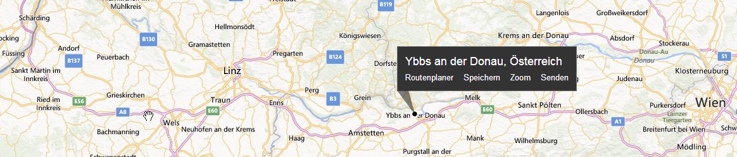
Wienn
Salzburg / Linz

If you come from the east (from Vienna):
Follow Highway A1 to Salzburg / Linz till exit Ybbs (100 km from Vienna)

If you come from the west :
Follow Highway A1 to Vienna till exit Ybbs

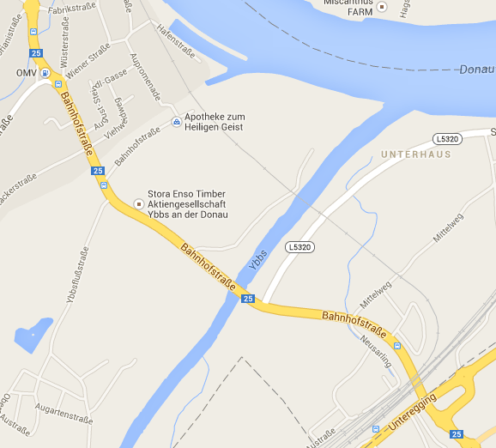
A1 Exit Ybbs

At the first traffic circle you go to the right to City Ybbs, follow the street (B25 - Bahnhofstrasse)

always straight ahead till traffic circle (left site OMV – Gasstation) go to right Wienerstrasse

always straight ahead to Hafenstrasse
Area Over View
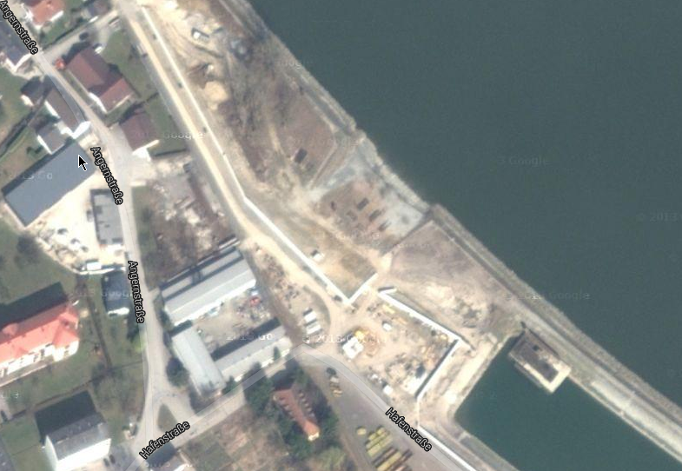
Boat Slipping
Habor
Camping Area

Boat Parking

Club House / Office

Race Area
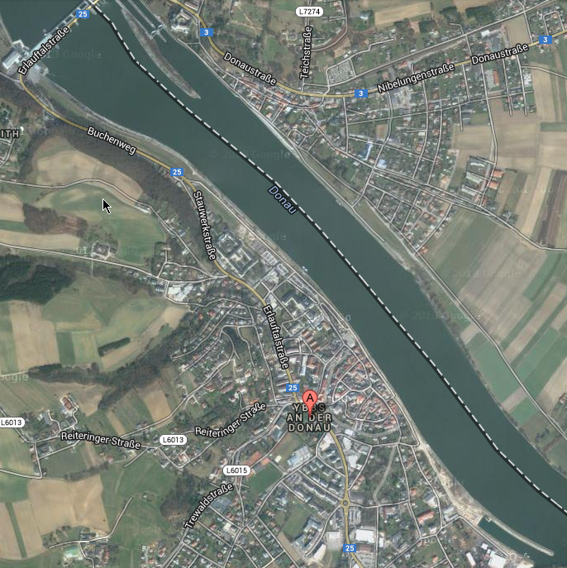
Race Area:

On Danube direct in City of Ybbs

No possibility to crane the boats !!
2 Cars for slipping

E&A. ENTRY FORM - FORMULAIRE D’ INSCRIPTION
FZSV Spk. Ybbs RACE 2014

EVENT : EUROPEAN CUP Date : 31-05-2014 Lieu / Venue : Ybbs (Austria)

FEDERATION : Team N° : ............... Nationality :.....................

O F I - MEN O F I – LADIES O MASTERS/SENIORS
O F III - MEN O F II – LADIES O JUNIORS
O FIII - MEN O FII I- LADIES O EURO-KIDS B / A

Skier/Skieur : Name :..................................................................................................
International Racing License: ............................................................
Address: ....................................................................................................
Date of birth: ....... / ....... / 19...... Blood type: ......................

Driver/Pilote: Name:..................................................................................................
International Racing License: .....................................................
Address: ....................................................................................................
Date of birth: ....... / ....... / 19...... Blood type: ......................

Observer/Observateur: Name:.................................................................................................
International Racing License: .....................................................
Address: ....................................................................................................
Date of birth: ....... / ....... / 19...... Blood type: ......................

Team - captain: Name:..............................................................................................................
Address: ....................................................................................................

Boat: Boat: .......................................... Type: ...............................
Motor: ....................................... Type: ...............................
Cc.: .............................. cc. H.P.: ..........................
Owner: ...............................................
Insurance: ....................................... Valid until ....................20.. ....

Declaration: - I declare to be the person responsible for the use of this boat.
- I declare to adhere to the rules governing the competition and to the rules of the I.W.W.F. - I declare to know that the organisers are in no way responsible for any happening, incident or accident during the competition.
- I declare that the raise cables, ropes or strings and accessories used to put the boat in and out of the water with the crane, are inspected by a recognised institute for controlling these items and according to the safety regulations as applicable in my country.
- I declare that all risks cause bodily harm or material damage to a third party, are covered by a third party liability insurance. The participants are third parties amongst them.

Skier Driver Observer Official Federation
Signature

Name Name Name Name/Position

WAIVER AND INDEMNITY

I represent my country, _______________________________________, and participate in the 2014 European Cup Waterski Racing Competition to be held in Austria Ybbs on 31.May 2014.

- I HEREBY EXPRESSLY ACKNOWLEDGE AND AGREE THAT THE ACTIVITIES OF THE COMPETITION ARE VERY DANGEROUS AND INVOLVE THE RISK OF SERIOUS INJURY AND/OR DEATH AND/OR PROPERTY DAMAGE AND THE UNDERSIGNED ASSUMES ALL SUCH RISKS. I expressly agree that the foregoing release, waiver, and indemnity agreement is intended to be as broad and inclusive as is permitted by the laws of Austria in which the event is conducted as well as the laws of any jurisdiction from which a participating federation is domiciled and that if any portion thereof is held invalid, it is agreed that the balance shall, notwithstanding, continue in full legal force and effect.

- I AGREE to abide by the Rules of the International Water Ski and Wakeboard Federation (“IWWF”) and the Österreichischer Wasserski und Wakeboard Verband (“ÖWWV”) including any additions or amendments thereto AND FURTHER AGREE to comply with all instructions given by the IWWF, the ÖWWV and the Organizers of the Competition.

- I ACKNOWLEDGE and agree that I fully accept responsibility and liability for any act or activities of myself during the Competition and am involved in the Competition at my own risk. I HEREBY RELEASE, WAIVE, DISCHARGE and COVENANT not to sue in any jurisdiction, the IWWF, the ÖWWV, the Organizers or their respective officials, servants, representatives or agents, individually or collectively, and fellow competitors from or for any and all liability to me for all loss or damage for bodily injury, death or damage to property as a result of my competing and/or practicing, officiating, observing, working for, or otherwise participating in the Competition howsoever arising notwithstanding that the same may have been contributed to or occasioned by the negligence of the said persons, bodies, their officials, servants, representatives or agents.

- Notwithstanding the above, I HEREBY INDEMNIFY the IWWF, the ÖWWV, and the Organizers of the Competition together with their respective officials, servants, representatives or agents from and against any actions, claims, costs, expenses and demands in respect of death, injury, loss of, or damage to the person and/or property of myself, my driver(s), my skier(s), my observer(s) or any other person(s) as the case may be arising out of or in connection with my competing and/or practicing, officiating, observing, working for, or otherwise participating in the Competition howsoever arising notwithstanding that the same may have been contributed to or occasioned by the negligence of the said persons, bodies, their officials, servants, representatives or agents.

- I confirm that “I” and “my” includes my personal representatives, heirs, next of kin, successors and assigns.

Name: ______________________ Passport No.: _________________________

Date: _______________________ Signature: ____________________________

